**Learning objectives class 4 Pedigree analysis**

**By the end of this topic you should be able to:**

* **Identify the following symbols**

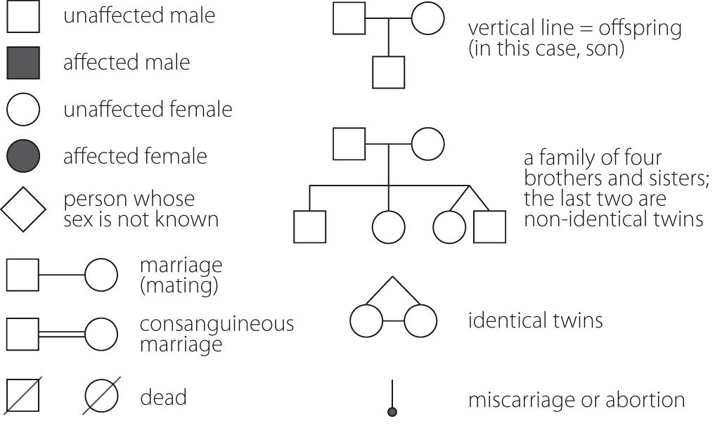

* **Recognise the patterns of inheritance of the following pedigrees:**
  + Autosomal recessive inheritance
  + Autosomal dominant inheritance
  + X-linked dominant inheritance
  + X-linked recessive inheritance
  + Y-linked inheritance
* **Recognise the patterns of mitochondrial inheritance and be able to identify the number of mitochondrial phenotypes in a mitochondrial gene pedigree (clue- don’t forget grandpa generation I and the females marrying in generation II & III)**

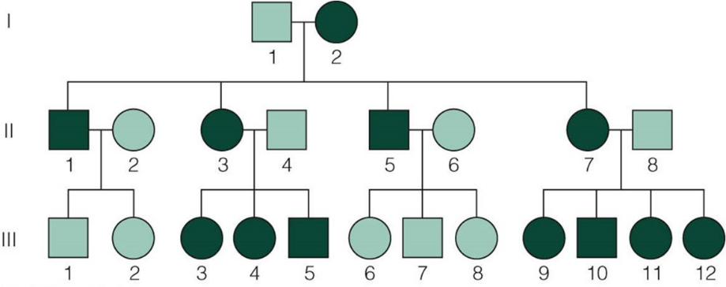

* **Recognise added complexity in pedigrees:**

-variations in gene expression

-age of onset expression patterns

-penetrance

-expressivity

* **Work through the supplementary practice problems until you can recognise the patterns: (clue- work via a process of elimination based on what you know for each inheritance pattern).**